Kidney Club Conference

December 10, 2025

Purpose
1 hour educational session presenting UCI faculty overview of late-breaking trials.

Target Audience
Specialties – Medicine, Nephrology, Hypertension & Kidney Transplantation
Professions – Physician, Non-Physician, Medical Student, Nurse, Nurse Practitioner, Other, Resident Physician

Activity Objectives
1 Analyze Current guidelines and develop a strategy to apply in the overall care of patients with CKD, kidney transplants, hypertension, fluid, electrolyte and acid base disorders
2 Critically review and analyze the care of patients undergoing renal replacement therapy using national guidelines and best practices
3 Critically analyze data from clinical research findings or updated care guidelines and apply it to the care of patients

Accreditation Statement
The University of California, Irvine School of Medicine is accredited by the Accreditation Council for Continuing Medical Education to provide continuing medical education for physicians.

Designation Statement
The University of California, Irvine School of Medicine designates this Live Activity for a maximum of 1.00 AMA PRA Category 1 Credit(s)™. Physicians should claim only the credit commensurate with the extent of their participation in the activity.

California Assembly Bill 1195 and 241
This activity is in compliance with California Assembly Bill 1195 and 241, which require CME activities with patient care components to include curriculum in the subjects of cultural and linguistic competency & implicit bias. It is the intent of AB 1195 and AB 241 to encourage physicians and surgeons, CME providers in the State of California, and the Accreditation Council for Continuing Medical Education to meet the cultural and linguistic concerns of a diverse patient population and reduce health disparities through appropriate professional development. Please see the CME website, https://www.meded.uci.edu/CME/ for AB 1195 and AB 241 resources.





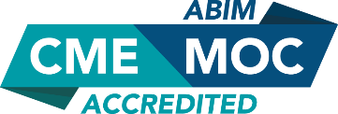

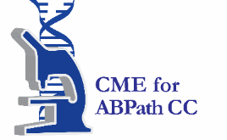

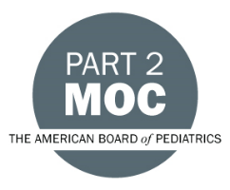

Faculty & Planner Disclosures
University of California, Irvine School of Medicine Continuing Medical Education adheres to the ACCME’s Standards for Integrity and Independence in Accredited Continuing Education. Any individuals in a position to control the content of a CE activity, including faculty, planners, reviewers, or others are required to disclose all relevant financial relationships with ineligible entities (commercial interests). All relevant conflicts of interest have been mitigated prior to the commencement of the activity.

Name of individual | Individual's role in activity | Nature of Relationship(s) / Name of Ineligible Company(s)
Shubham Dixit, DO | Faculty | Nothing to disclose - 11/26/2025
Wei Ling Lau, MD | Course Director, Faculty | Nothing to disclose - 06/16/2025
Stefaney Mendoza, BA | Activity Coordinator | Nothing to disclose - 10/30/2025
Uttam G Reddy, MD | Faculty | Nothing to disclose - 06/16/2025
John Sy, MD | Co-Director | Nothing to disclose - 01/27/2025
Steven Vasquez | Activity Coordinator | Nothing to disclose - 10/21/2025

Agenda
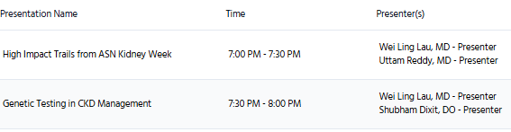

Acknowledgement of Commercial Support
We wish to thank Natera for exhibiting at this event.

